**1) (2pts) Chapter 5 Text Book Problem 9.** Additional information: use 1Gbps = 1x109 bits per second. On part b) the book is asking about the numbers for the Bandwidth, RTT and maximum segment lifetime

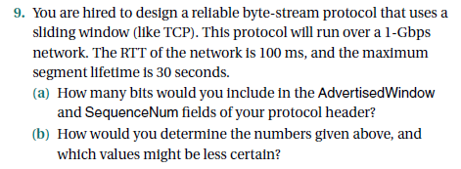

**2) (2pts) Chapter 5 Text Book Problem 12.** Additional information: 1Gbps = 1x109 bits per second. For part b, the 32 bit timestamp field is incremented by 1 and it is incremented 1000 times during the time it takes the sequence numbers to wrap around (i.e. if the sequence numbers wrap every 15 seconds, then after 15 seconds the timestamp field has incremented 1000 times)

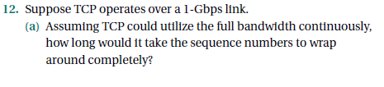

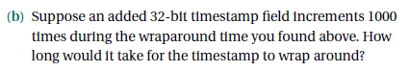

**The Jacobson/Karels Algorithm uses (unless stated otherwise) delta = 1/8, µ = 1.0 and Φ = 4.0.**

**3) (3pts) Modified Chapter 5 Text Book Problem 26.** Use matlab, excel (works great) or a program to perform the analysis on this problem. The initial iteration information is shown below.

a) Perform the calculations using a starting deviation value of 0.5 and a delta of 1/8

b) Perform the calculations using a starting deviation value of 1.5 and a delta of 1/8. How sensitive is the algorithm to the choice of 1.5 for the deviation and the choice of 0.5?

c) Perform a third calculation using a starting deviation of 0.5 and a delta of 1/4. How do the results for these parameters compare to results from using a deviation of 0.5 and a delta of 1/8.

|  |  |  |  |  |  |
| --- | --- | --- | --- | --- | --- |
| **Iteration #** | **Sample RTT** | **Estimated RTT** | **Deviation\*** | **Difference** | **Timeout** |
| **0 starting values** | **-** | **4.0000** | **0.5000** | **-** | **-** |
| **1** | **1.0000** | **3.6250** | **0.8125** | **-3.0000** | **6.8750** |

*Starting Deviation will be 0.5 or 1.5 to start each of the three calculations.

Iteration #1 shows result for when the starting deviation value is 0.5. It will be different for an initial deviation of 1.5

In the formulas for the Jacobson/Karels algorithm, you need to figure out which numbers are used from the previous iteration and which ones are used from the current iteration to come up with the calculated values for the current iteration. **You are looking to run the calculations until the Timeout time drops below 4 seconds. Show your numbers with 4 decimal places**

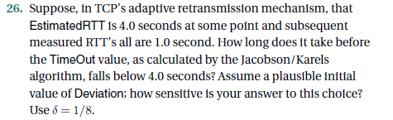

***4) (3pts) Use the Estimated RTT and timeout formulas on page 418 (These are the original timeout algorithm formulas) to determine the TCP timeout value for 30 sample RTTs that arrive as described next.*** *Perform the analysis for 30 sample RTTs using five sample RTTs of 1.000 followed by one RTT of 5.000 (then repeat this pattern, so RTT is 5.0 for iteration 6, 12, 18, 24, etc). Use a starting (current) estimated RTT of 1.50*

*a) Perform the analysis using α = 0.5*

*b) Perform the analysis using α = 0.8*

*b) Perform the analysis using α = 0.9*

*d) How much of an effect did the value of α have on the timeout values calculated?*

